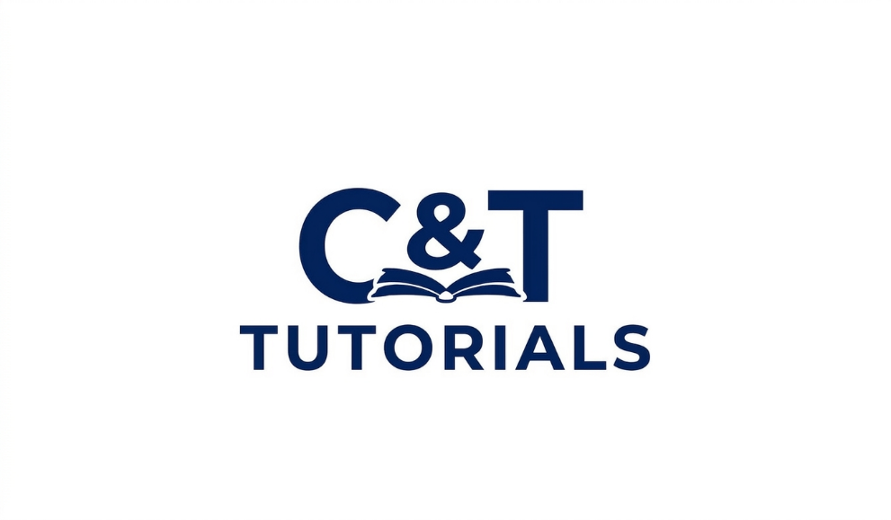

Lesson Plan Template
  - 1. Basic Information
Tutor Name:
Subject:
Topic:
Grade/Level:
Date:
Session Duration:

  - 2. Lesson Objectives

(What should the student achieve by the end of the session?)

  - 3. Prior Knowledge Assessment

(What does the student already know about the topic?)

  - 4. Materials & Resources
- (List all materials needed for the lesson)
- Textbook(s):
- Worksheets:
- Online tools/resources:
- Other:

  - 5. Lesson Structure

A. Introduction (5–10 minutes)
- Warm-up activity:
- Review of previous lesson:
- Introduction to new topic:

B. Lesson Development (Main Teaching)
(Break into steps if needed)
Step 1:
- Explanation:
- Example(s):

Step 2:
- Explanation:
- Example(s):
Step 3 (if applicable):
- Explanation:
- Example(s):

C. Guided Practice
(Work through problems together)
- Activity 1:
- Activity 2:

D. Independent Practice
(Student works alone)
- Task(s):

E. Assessment & Feedback
(Check understanding)
- Questions asked:
- Observations:
- Areas of difficulty:

  - 6. Differentiation / Adaptation

(How the lesson is adjusted for the student’s needs)

  - 7. Homework / Follow-Up Tasks

8. Reflection (Tutor Only)
(After the session)
- What went well:
- What needs improvement:
- Plan for next lesson:

  - 9. Student Progress Tracking
- Strengths:
- Weaknesses:
- Overall Progress Rating

C&T TUTORIALS
Your Academic Support Partner
Contact: +264815621879/+264818479958
Email: ct0tutorials@gmail.com

